 Instructions for using NDP.view2 in MacOs
- Go to System Settings in your Mac
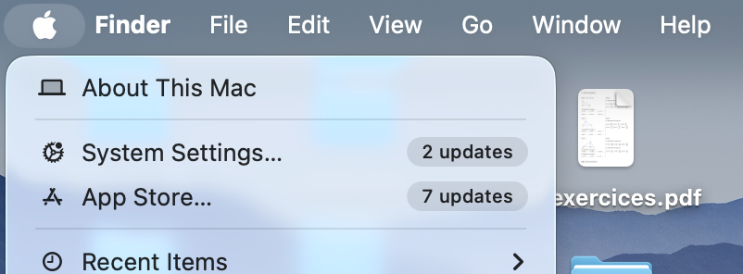
- Select Privacy and Security
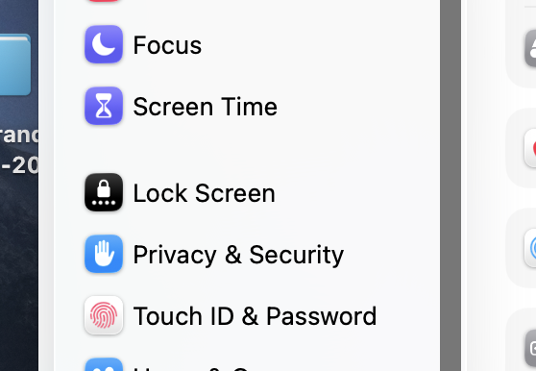
- Select Full Disk Access
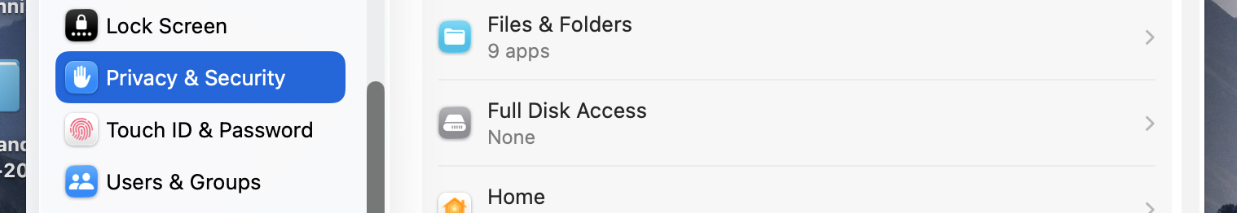

- Scroll down to Terminal and give Full access by sliding the plug (you will have to type your password when required)
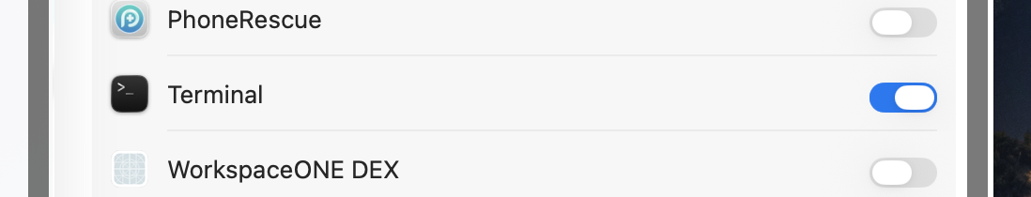
- Double-click on the icon startup.command and wait until the tool gets installed in your machine. You do not need to do anything



- The application NDP.view2 is located in the folder Applications (next to all the other programs in your computer). You can delete if from there after you have finished the course.

- All data is in the folder /Users/<your-username>/Desktop/NDP-view2/data

